**APPLICATION TO EXHIBIT**

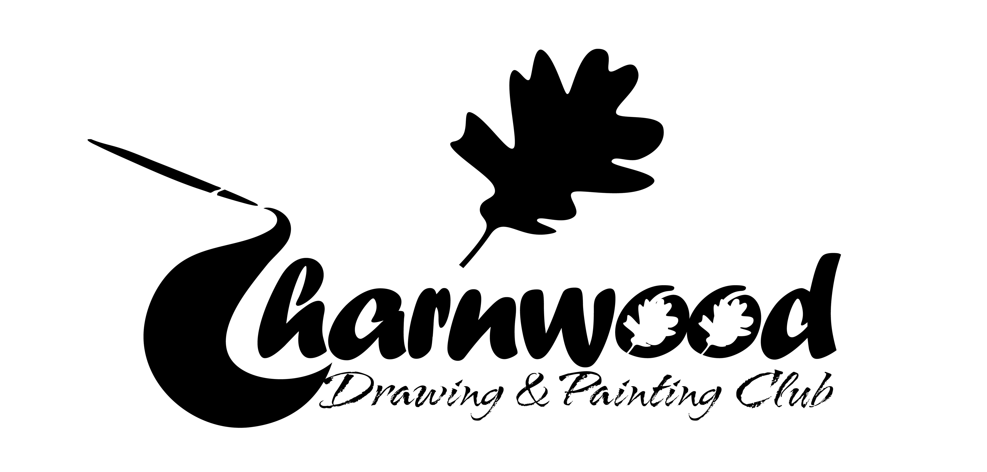

**NEWTOWN LINFORD EXHIBITION**

**Next to main entrance BRADGATE PARK**

**29-31 August 2014**

**Entries to be in by latest 26 August club night or post to:**

**Joy Lockton, 260Forest Road, Loughborough LE11 3HX. Tel: 01509 821376**

Name _________________________________________________________________

Address_________________________________________________________________

_____________________________________Postcode__________________________

Telephone No:_________________________

Exhibitors can enter, up to 4 framed and unlimited unframed paintings, and ceramics. Hanging space is limited and works not able to be hung will be held in reserve. Unframed PRINTS can be exhibited but NO framed ones If possible we would like entries of new works which have not been exhibited before If submitting Greetings cards please mark clearly with the artists name and record number of cards exhibited (see attached form).

***Due to rising costs of exhibitions we have had to implement a 10% commission on each sale which will go to club funds so please take this into account when you price your work.***

**ENTRY FEE:** £2.00 per Framed £1.00 per unframed **FEE PAID £---------------**

*Please print clearly in BLOCK CAPITALS*

|  |  |  |
| --- | --- | --- |
| **FRAMED** **Title** | **Medium** | **Price/NFS** |
|  |  |  |
|  |  |  |
|  |  |  |
|  |  |  |
| **UNFRAMED* Title** | **Medium** | **Price/NFS** |
|  |  |  |
|  |  |  |
|  |  |  |
|  |  |  |
|  |  |  |
|  |  |  |

* **- - - - - - - - - - - - - - - - - - - - - - - - - - - - - - - - - - - - - - - - - - - - - - - - - - - - - - - - - - - - - - - - - -**

**Please ensure exhibits are delivered to : Newtown Linford Sunday School (outside main entrance Bradgate Park) on Thursday 29 August between 4pm – 5pm (any problems with this get in touch with a committee member). Pictures cannot be collected until 5pm on Sunday 31 August 2014**

1. Pictures must be clearly labelled on the back with name of artist, title, medium and price or NFS. (labels to display alongside your paintings will be provided by the club).
2. Pictures must be suitably framed and ready for hanging with screw eyes and cord.
3. *Unframed pictures must be mounted and cellophaned, PLEASE MAKE SURE PAINTINGS ARE NEATLY AND SECURELY WRAPPED, cling film is not acceptable.
4. The organisers cannot be held responsible for any loss, theft or damage during the exhibition or in transit.
5. All exhibitors will be expected to help if possible during the Exhibition as it may be busy. (A stewards rota will be circulated during Club nights).
6. **PLEASE RETAIN THE BOTTOM HALF OF THIS FORM FOR YOUR REFERENCE**

**GREETING CARD LIST**



**NEWTOWN LINFORD EXHIBITION**

**Next to main entrance BRADGATE PARK**

**29/31 August 2014**

**If you are supplying cards for the exhibition please fill in below, the far right column will be used at the exhibition to indicate the number sold:**

|  |  |  |  |
| --- | --- | --- | --- |
| **CARD TITLE** | **No. Cards supplied** | **Price per card** | **(For sales at exhibition)**  **No. Sold** |
|  |  |  |  |
|  |  |  |  |
|  |  |  |  |
|  |  |  |  |
|  |  |  |  |
|  |  |  |  |
|  |  |  |  |
|  |  |  |  |
|  |  |  |  |
|  |  |  |  |

Name _________________________________________________________________

Address_________________________________________________________________

_____________________________________Postcode__________________________

Telephone No:_________________________

**Please return to:**

**Joy Lockton 260 Forest Road, Loughborough LE11 3HX. Tel: 01509 821376**